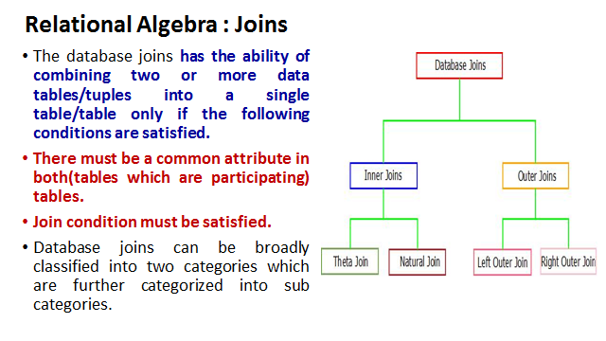

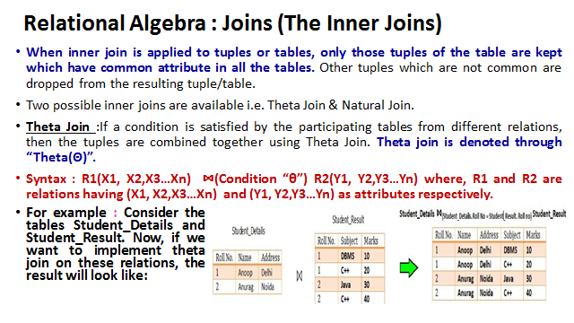

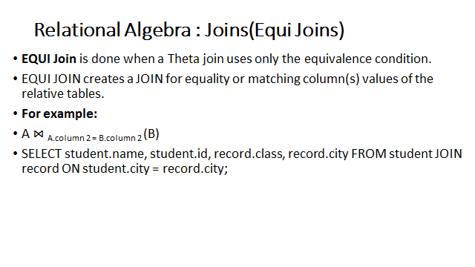

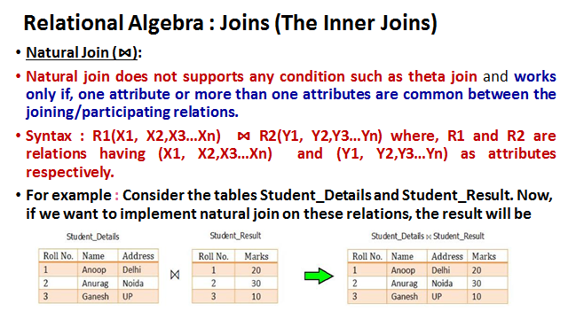

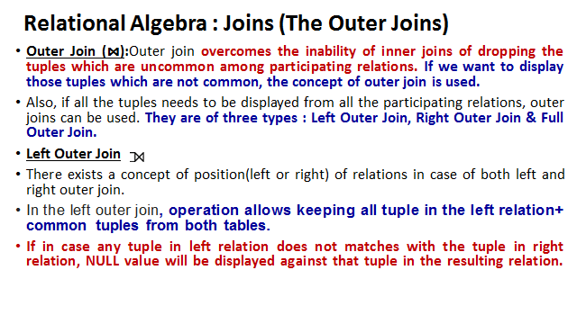

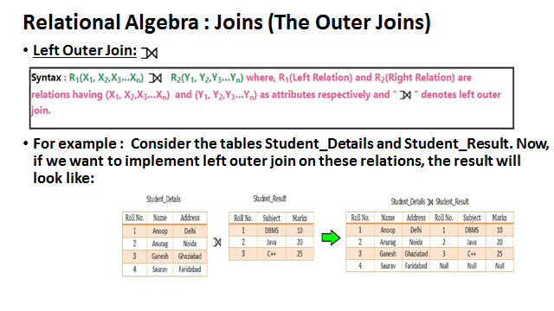

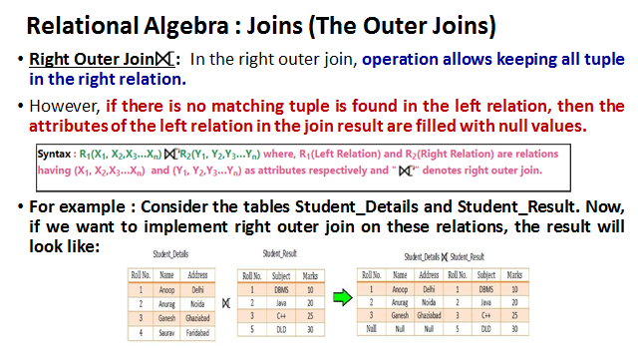

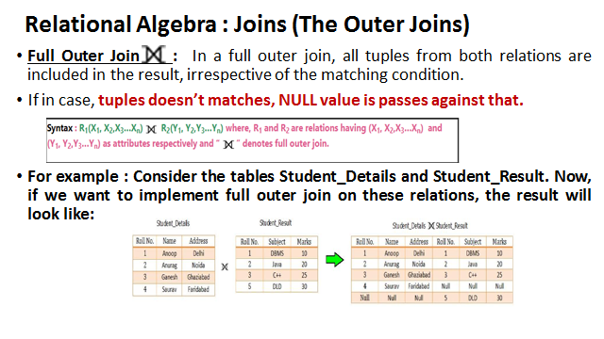

1. **Equi Join**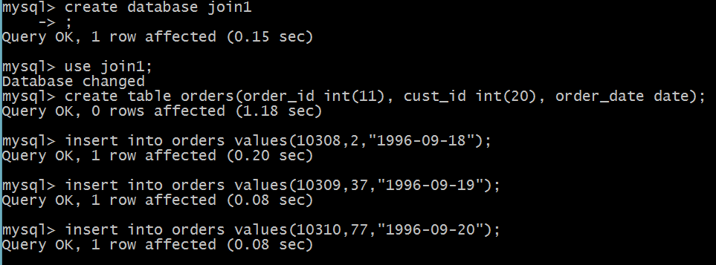

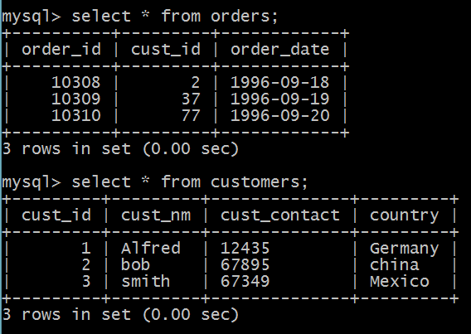



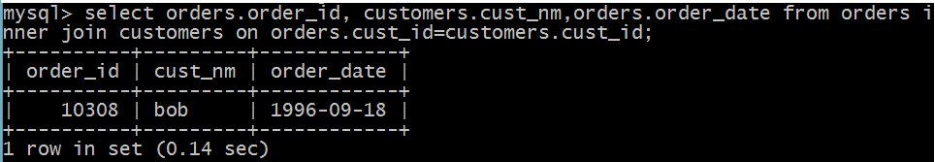

As the only customer id 2 is common in both tables, it is only retrieved.

**2 Theta Join**

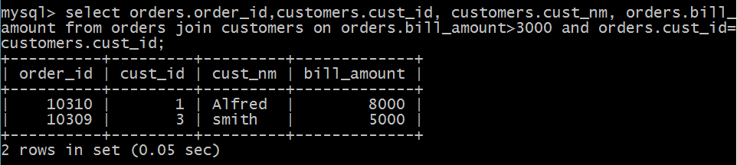

**3.Natural Join**

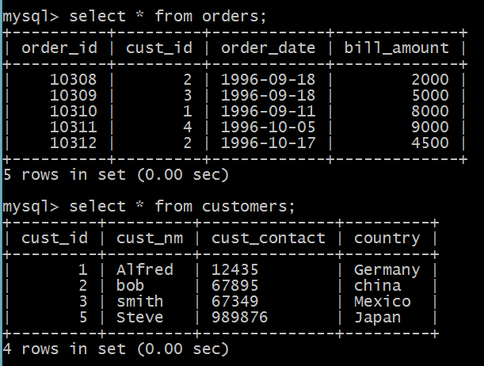

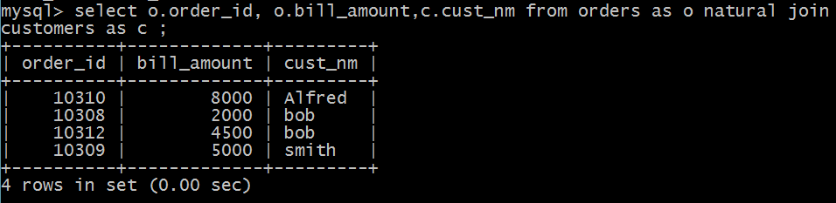

**3.Left Outer Join**

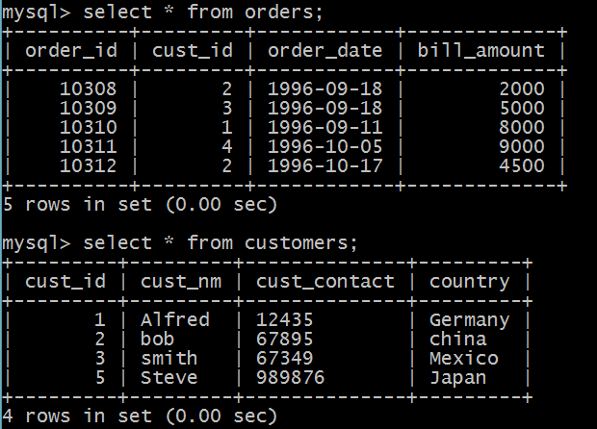

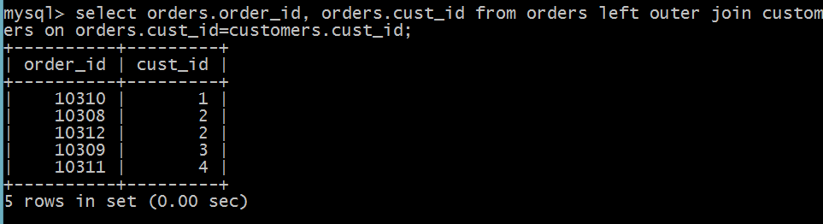

**4.Right Outer Join**



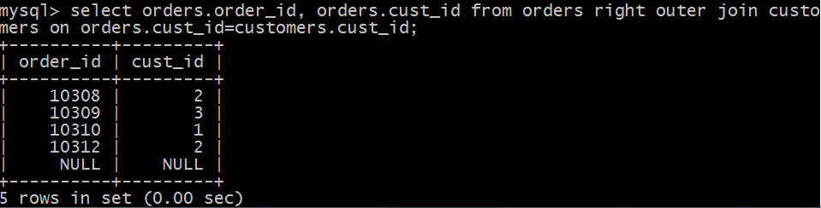

**5. Full Outer join**

FULL OUTER JOIN Syntax

SELECT *column_name(s)*  
FROM *table1*  
FULL OUTER JOIN *table2*ON *table1.column_name*=*table2.column_name*WHERE *condition*;

**6. SQL Self Join**

A self join is a regular join, but the table is joined with itself.

### Self Join Syntax

SELECT *column_name(s)*  
FROM *table1 T1, table1 T2*  
WHERE *condition*;

